HERRING LIFE CYCLE
It’s a risky journey

Play this game to explore the hazards and successes herring encounter on their journey through life. A series of numbered cards are placed by these cones. Follow these steps to see if you survive!

- To start your journey, roll the die and begin on the card with the number you roll.

- Follow the instructions on each card. When conditions are favorable, the card will tell you to move ahead. When you encounter a hazard, you may be delayed or you may have to go back to the beginning. Sometimes you will need to roll a die.

- REMEMBER! Not all herring survive to return to spawn. Some will live and some will die.

- Good luck on your journey!
1
Your eggs were successfully laid, fertilized and attached to kelp. Roll ahead 2 stations.

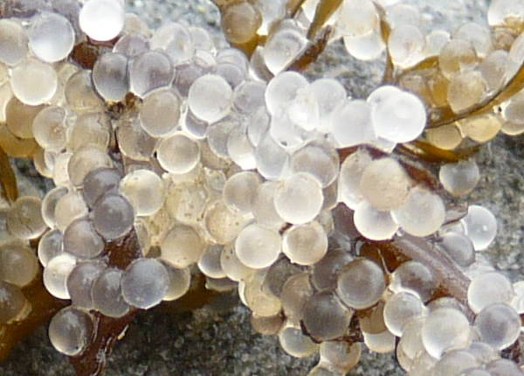
2
Oh no! Your eggs were not fertilized. Fall down and roll back to the beginning. Start over.

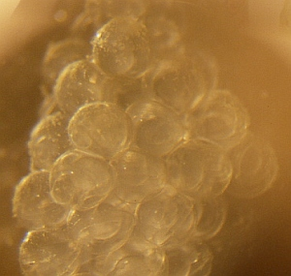
3
Your eggs failed to stick to vegetation and you drifted out to sea. Roll back to start.

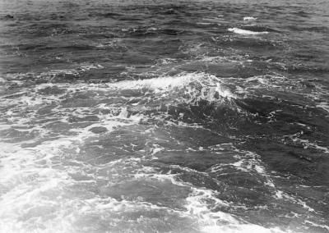
4
SORRY! Your eggs were crushed by shoreline development. Stomp your feet back to start.

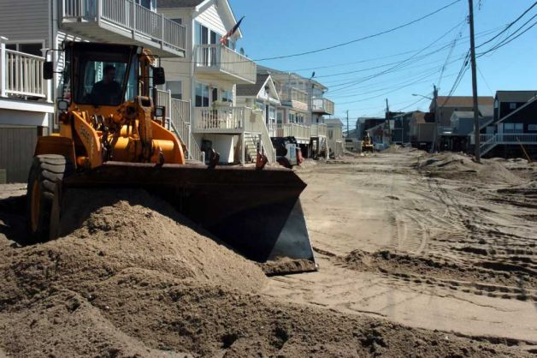
5
You found a protected kelp forest to shelter you for 21 days until you hatch. Swim around the cone 4 times. Roll the die and move ahead that number of stations.

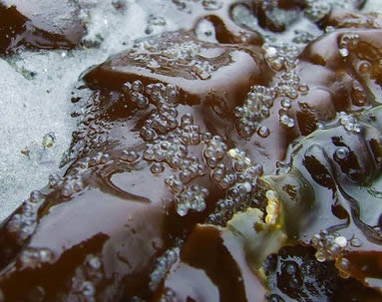
6
Ugh! Your eggs were covered in oil and can no longer develop normally into a healthy herring. Slide your feet back to start.

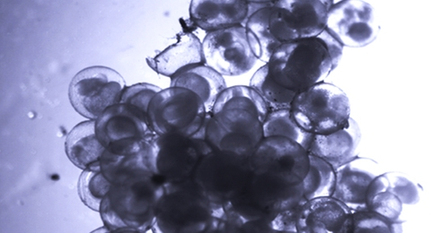
7
MMM! MMM! Your eggs tasted delicious. A gull ate you for breakfast. SORRY! The game is over for you. Crawl back to the beginning and start again.

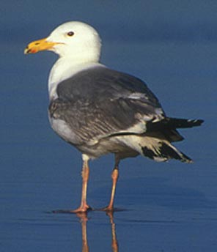
8
Ouch! The temperature of the water in your spawning ground is too high. Hold your breath for 5 seconds and roll the die to move back that number of stations.

9
Your eggs are harvested for sushi in a Japanese restaurant. Jump back to start.

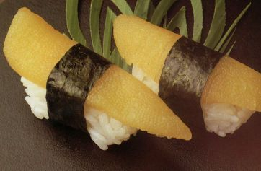

10
Uh oh! The salinity of the water in your spawning ground is too high. Hold your breath for 5 seconds and roll the die to move back that number of stations.
11
You survived! Hatch and become a larva with a fully developed yolk sac. Roll die and drift ahead with the current that number of stations.
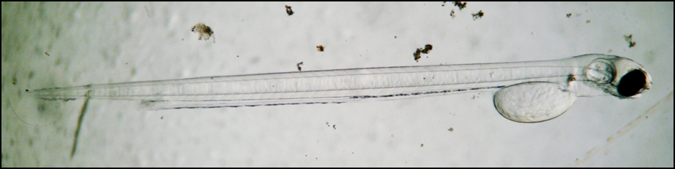
12
After absorbing your yolk sac, you can’t find enough plankton to eat. Go back one station.

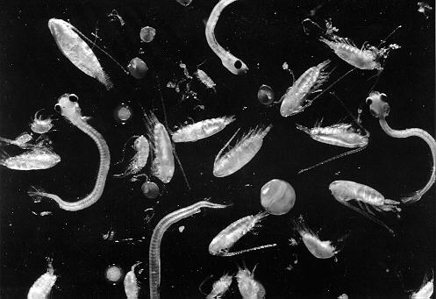
13
Watch out for the salmon. It wants to eat you! Freeze, count to 10 and then sneak ahead 2 stations.

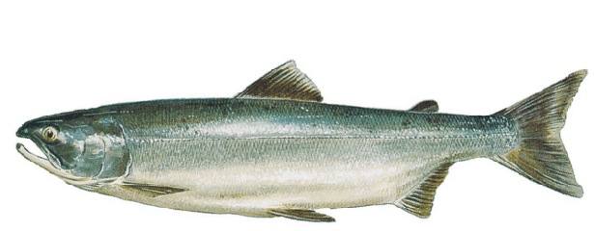
14
You are caught by fishermen for your roe. SORRY! The game is over for you. Hop back to start.

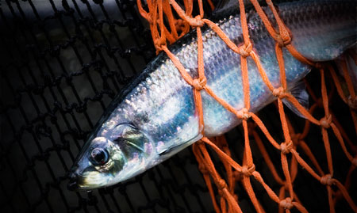
15
Oops! You are lost at sea and failed to move inshore to spawn. Swim back 4 stations.

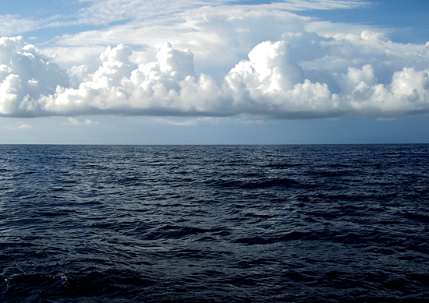
16
A mink catches you and eats you. The game is over. SORRY! Die dramatically, then go back to the beginning and try again.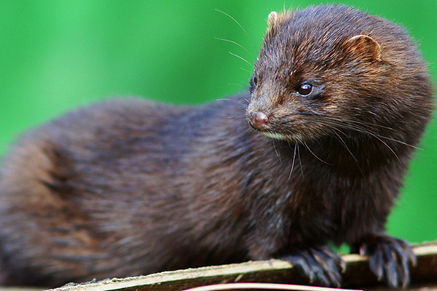
17
You successfully made it past the fishermen, bears and other dangers and returned to the intertidal zone to spawn. Run around the entire cycle 1 time and begin again as an egg.

