*Exxon Valdez* Oil Spill

Long-Term Herring Research and Monitoring Program Final Report

Scales as growth history records

Restoration Project 13120111-N

Final Report

Steven D. Moffitt

Alaska Department of Fish and Game

Division of Commercial Fisheries

401 Railroad Avenue  
P.O. Box 669  
Cordova, AK 99574-0669

March 2017

The *Exxon Valdez* Oil Spill Trustee Council administers all programs and activities free from discrimination based on race, color, national origin, age, sex, religion, marital status, pregnancy, parenthood, or disability. The Council administers all programs and activities in compliance with Title VI of the Civil Rights Act of 1964, Section 504 of the Rehabilitation Act of 1973, Title II of the Americans with Disabilities Action of 1990, the Age Discrimination Act of 1975, and Title IX of the Education Amendments of 1972. If you believe you have been discriminated against in any program, activity, or facility, or if you desire further information, please write to: EVOS Trustee Council, 4230 University Dr., Ste. 220, Anchorage, Alaska 99508-4650; or O.E.O. U.S. Department of the Interior, Washington, D.C. 20240.

*Exxon Valdez* Oil Spill

Long-Term Herring Research and Monitoring Program Final Report

Scales as growth history records

Restoration Project 13120111-N

Final Report

Steven D. Moffitt

Alaska Department of Fish and Game

Division of Commercial Fisheries

401 Railroad Avenue  
P.O. Box 669  
Cordova, AK 99574-0669

March 2017

Scales as growth history records

Restoration Project 13120111-N

Final Report

Study History: This report summaries work documented in Herring Research and Monitoring program annual reports HRM 2012-12120111, HRM 2013-13120111, and HRM 2014-14120111, Science synthesis report for the Herring Research and Monitoring program 14120111.

Abstract: Pacific herring (*Clupea pallasii*) scales have been collected in Prince William Sound and archived since 1973. These scales contain a retrospective, longitudinal growth history that this project worked to capture. Using a spatially-calibrated scanning microfiche this project collected digital images of randomly selected herring scales. Annual scale growth increments were measured from the images using image analysis software. Data were subject to quality control analysis and precision of the scale measurements was evaluated by a blind second measurement of random selected scales. Correlation analyses of these scale growth history data and environmental and biological data have, in a related paper, helped explain some of the growth drivers for Pacific herring in Prince William Sound.

Key words: Alaska, *Clupea pallasii*, Growth, Longitudinal Study, Pacific herring, Prince William Sound, scales.

Project Data: Data include Prince William Sound, Alaska, Pacific herring scale annular increment measurements for fish aged 4, 5, and 6 by sex and year (1982–1983, and 1985–2015). These data are paired with sex, size, approximate location, sample date, harvest type, and sampling gear. Data are available in Excel at the Alaska Department of Fish and Game office in Cordova. These data have also been provided to the Alaska Ocean Observing System for dissemination and archiving.

Current Data Custodian:

Steve Moffitt

Alaska Department of Fish and Game

P.O. Box 669

Cordova, Alaska 995574

907-424-3212

Steve.moffitt@alaska.gov

Citation: Moffitt, S.D. 2017. Retrospective longitudinal growth history from scales of Pacific herring collected in Prince William Sound. Exxon Valdez Long-Term Herring Research and Monitoring Program Final Report (Project 13120111-N).

Table of Contents

List of Tables iii

List of Figures iii

List of Appendices iii

Executive Summary 1

Introduction 1

Objectives 2

Methods 3

Study Area 3

Sample Archive 3

Sample Size 3

Pre-processing Setup 3

Scale Processing 4

Quality Control 5

Precision Test 6

Growth Correlations 6

Results 6

Scale Images and Measurements 6

Quality Control 6

Precision Test 7

Growth Correlations 7

Discussion 9

Scale Images and Measurements 9

Quality Control 9

Precision Test 9

Growth Correlations 9

CONCLUSIONS 10

Acknowledgements 10

Literature Cited 10

Appendices 13

Scales as growth history records

List of Tables

Table 1–Count of Pacific herring scales imaged and measured for annular growth increments, 1982, 1983, and 1986–2015. 6

Table 2–Wilcoxon signed-rank tests of paired measurements of scales marked as outliers. 7

Table 3–Results of linear regression models of paired measurements of randomly selected herring scales aged 4-6 combined. 7

Table 4–Pearson correlaton coefficients of the first year of herring scale growth by age (sexes combined) and the log of age structured model estimates of adult herring biomass for growth years 1976-2011. 8

List of Figures

Figure 1–Preferred body areas to collect Pacific herring scales for age interpretation. 4

Figure 2–Example Pacific herring scale with measurement overlay from image analysis software 5

Figure 3–Average scale growth annuli (mm) and 95% confidence intervals for the first year ofgrowth of age-6 Pacific herring captured in early spring in Prince William Sound, Alaska for Growth years 1980–2009. 8

List of Appendices

Appendix 1–Count of Prince William Sound Pacific herring scales that were imaged and growth annuli measured by year. No scales were measured for 1984. 13

Executive Summary

This project documents Herring Research and Monitoring Project 13120111-N. Two main objectives were outlined for this project. The first objective included several items: standardize our scale age interpretive criteria for Pacific herring (*Clupea pallasii*), evaluate alternative measurement methods for scale growth increments, and develop semi-automated methods to measure scales. The second objective was to image and measure scale growth increments on as many fish as possible. The first objective was met starting in the fall of 2012 after travel to Juneau to meet staff at the statewide mark, tag, and age lab to learn about the equipment and methods. Equipment was then purchased to take digital images of scales and software to measure the scale increments. A random selection of herring scales of ages 4, 5, and 6 at collection, equally split between sexes, were chosen to image and measure. The second objective was adjusted to measure scales from 30 fish of each sex for ages 4–6 for as many years as possible beginning with the recent years. A total of 7,270 scales were imaged and measured and an additional 3,500 scales were imaged but not measured because the reader did not agree with the assigned age or the scale had morphological problems (e.g., torn or folded edges, or asymmetrical shape) that would not allow measurements. The data were evaluated for outliers using statistical software, scatter plots, and box plots. Statistical outliers (57) were imaged and measured a second time, but analysis indicated the second measurements were not significantly different from the first set considered outliers. A test of the precision of the measurements was conducted by randomly selecting 101 scales to be imaged and measured a second time. Analysis indicated there was no significant difference between the two sets of data when measurements of scale increments (e.g., first year growth) were combined across ages and sexes. This project has created a retrospective, longitudinal growth history of scale growth for Prince William Sound Pacific herring. These data have been and will be useful to help understand how environmental and biological factors affect herring scale growth.

Introduction

Fish grow in response to environmental conditions and are constrained by intrinsic influences of genetic predisposition for growth and current size (Weatherley and Gill 1987, Weisberg 1993). Understanding how growth is influenced by the environmental and genetic sources of variability is important for several reasons. Effects of stock size and environmental conditions on growth have been studied by many investigators (Anthony and Fogarty 1985, Hagen and Quinn 1991, Martinson et al. 2009, Peterman and Bradford 1987, Stocker et al. 1985), because growth variation can affect reproductive potential through its influences on fecundity and spawn timing (Ware and Tanasichuk 1989), natural mortality, recruitment, and age at maturity (Haist and Stocker 1985, Schmitt and Skud 1978). Haist and Stocker 1985 stated that factors affecting growth rates can be of fundamental importance to understanding the dynamics of exploited populations and responses of natural populations to abundance and environmental influences have remained a central issue in population biology (Tanasichuk 1997). Variation in growth affects the appropriate harvest policies based on demographic models that reflect natural processes (Methot 1997, Tanasichuk 1997).

The underlying mechanisms for changes in annular growth for herring in the northern Gulf of Alaska are still not completely understood. A period with the lowest observed average body sizes for Prince William Sound (PWS) Pacific herring (*Clupea pallasii*) coincided with a period of historically high abundance followed by a large population decline associated with outbreaks of viral hemorrhagic septicemia virus (VHSV) and (*Ichthyophonus hoferi*)(Marty et al. 1998, Marty et al. 2003, Marty et al. 2010); but see Elston and Meyers (2009). Although the links between herring growth and disease susceptibility are not yet well understood, it is hypothesized that the observed population decline resulted from density dependent growth causing decreased body condition and susceptibility to disease (Rice and Carls 2007). Analysis of annular growth increments on scales provide a retrospective, longitudinal growth history that will assist in evaluating environmental and density-dependent causes of growth variation.

Herring growth is currently understood based on cross sectional size at age data. In contrast, growth increment information incorporates a longitudinal history of growth that increases the effective degrees of freedom and can be used in modeling changes in growth in relationship to environmental and population indices (Chambers and Miller 1995, Kreuz et al. 1982, Tanaischuk 1997, Weisberg 1993). Determining the underlying distribution of individual growth patterns can provide improved inputs into population dynamics models used to establish harvest guidelines.

Age, sex, and size data from PWS Pacific herring have been collected by the Alaska Department of Fish and Game (ADF&G) from commercial fisheries, test fisheries, and fishery independent research projects since the early 1970s. The archive currently contains approximately 210,000 scales paired with size and sex data (most collected since 1979). Summaries of age, sex, and size data have been published for a portion of the time series (e.g., Sandone 1988*a*, *b*; Willette et al. 1999). Age, sex, and size processing methods are similar those described by Baker et al. (1991); however, electronic fish measuring boards were used to enter sample summary data and individual fish data (standard length in mm, whole body weight in grams, and sex) at the time of processing since 1989.

This project imaged and measured Pacific herring scales from the ADF&G archive in Cordova using methods described in Batten et al. (2016). The methods used for this project were similar to those described by Hagen et al. (2001) to image and measure annular growth increments of Pacific salmon (*Oncorhynchus* sp.) scales. The first year of this project was focused on developing the image processing methods and criteria. The second year of the project was primarily focused on measuring growth increments of randomly selected scales from the archived collection.

Objectives

1. FY2012:

a. Standardize scale interpretive criteria, evaluate alternative measurement techniques, and develop semi-automated procedures for measuring scale increments of PWS herring.

b. Measure scale growth increments on scales subsampled from archived collections.

2. FY2013:

a. Finish measurements of scale growth increments on subsampled scales.

Methods

Study Area

No field work was conducted for this project. A large existing Pacific herring scale archive maintained in the Cordova ADF&G office was the source of scales for the project. The scale archive is almost exclusively from the Prince William Sound Management Area which includes all state waters west of Cape Suckling (approximately -143.872° West Long.) and east of Cape Fairfield (approximately -148.844° West Long.). One purse seine test set collection is from Resurrection Bay near Seward in 1996 and 12 scales were used for this project.

Sample Archive

The PWS scale archive collections start in 1973, but more consistent and larger collections began in 1979. The archive contains approximately 210,000 scales classified by commercial harvest type (spring sac roe, pound, or fall food and bait fisheries) or research project type (acoustics, disease assessment, or spawning collection) by collection gear type (commercial purse seine, gillnet, or trawl gear; and research purse seine, cast net, variable mesh gillnet, or jigs).

Sample Size

The original project proposal indicated the number of scales to measure would be based on a power analysis with a preliminary goal of 50 scales from 6 or 7 age classes per year. However, a delay in hiring staff at the beginning of the project combined with the time required to acquire and setup equipment; modify the equipment for use with large Pacific herring scales, and calibrate the scanner, caused a later than anticipated start to production processing. Additionally, an examination of the number of scales available by age indicated that 60 scales per year (30 for each sex) for 3 age classes would be more likely to be completed with the available funds. The 3 age classes selected for this project were ages 4, 5, and 6 because an examination of the scale archive indicated the sample goal could be achieved more often than for the other age classes.

Pre-processing Setup

Prior to starting the project, project personnel met with staff at the ADF&G Mark-Tag-Age (MTA) Laboratory in Juneau to consult on standardizing scale interpretive criteria, evaluating alternative measurement techniques, and to develop semi-automated procedures for measuring scale increments. The MTA laboratory staff also provided guidance on the appropriate equipment, equipment setup and calibration; image analysis software, and data processing. MTA Laboratory staff members have extensive experience with fish scale image capture, annular measurements, and processing so using similar equipment and procedures saved a significant amount of development time and knowledgeable source for help.

Age interpretation criteria for this project were the same as shown by the pictorial guide of Lebida (1986) for Bristol Bay herring scales. Because an annulus forms on the scale margin in the spring, this project standardized on spring collections of scales from March, April, or May.

Prior to starting production scale imaging work, test scales were imaged with our Screenscan® microfiche scanner attached to an Indus® microfiche reader. Adjustments to the magnification were necessary to get all of the larger herring scales to fit in the image and a neutral density filter was added to increase contrast of the image. Additionally, the Image-Pro® Plus Software (Media Cybernetics, Inc. Rockville, Maryland) was spatially calibrated using a stage micrometer for the magnification objective used to measure growth increments.

Scale Processing

If available, 100 scales were randomly selected for each age (4, 5, and 6), sex, and year (1982–1983 and 1985–2015). This pool of 100 scales was necessary because not all scales were useable for this project. Scales were selected for imaging and measuring if they met the following criteria: (1) the scale reader agreed with the age previously assigned by ADF&G staff, (2) the scale appeared to be from the preferred area, and (3) the scale annuli were defined sufficiently to allow discrete measurements. Scales from the preferred areas 1–4 (Figure 1) were much more likely to be symmetrical with clearly defined annuli and baseline.

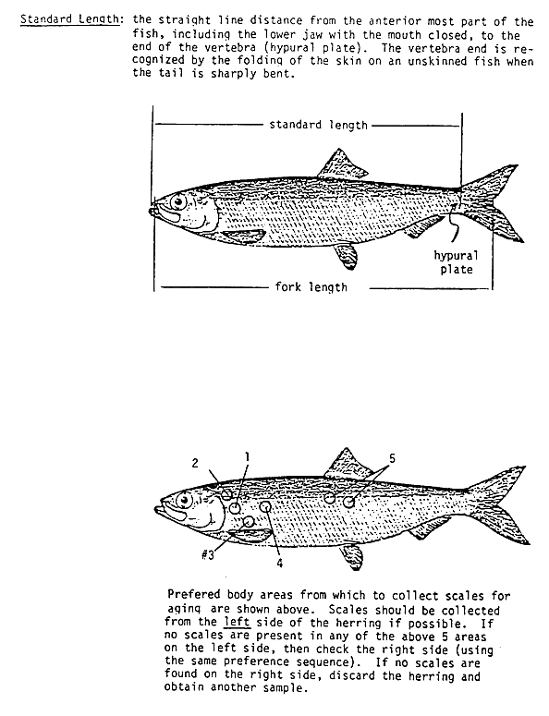

Figure 1–Preferred body areas to collect Pacific herring scales for age interpretation.

Scales were rejected for measuring if (1) the scale was asymmetrical such that the appropriate axis to measure along was unclear, (2) the scale quality would make measuring difficult or impossible. Most scales were acceptable for determination of total age, but were unsuitable for measuring growth increments because the scale was torn, folded, or had unusual growth patterns along the measurement axis of the scale.

Each randomly selected scale was imaged with a Screenscan® microfiche scanner attached to a microfiche reader. The scanned images are saved in a Tagged Image File Format (TIFF) with 8-bit depth sized at 3352 x 4425 pixels (14.5 Mb files). Images were saved to the ADF&G local area network and backed up to a remote server daily. Each image was given a unique file name that includes the age, sex, and size sample file name, scale slide or page number, scale fish number, sex, and age as originally assigned. File names include the year, harvest type, gear, and a location code.

Scale images were measured using Image-Pro® Plus Software and a fish scale measurement macro. Measurements were made on a measurement axis perpendicular to the reference line approximately through the scale focus (Figure 2). Each annulus was marked on the scale by the reader in the image analysis macro.

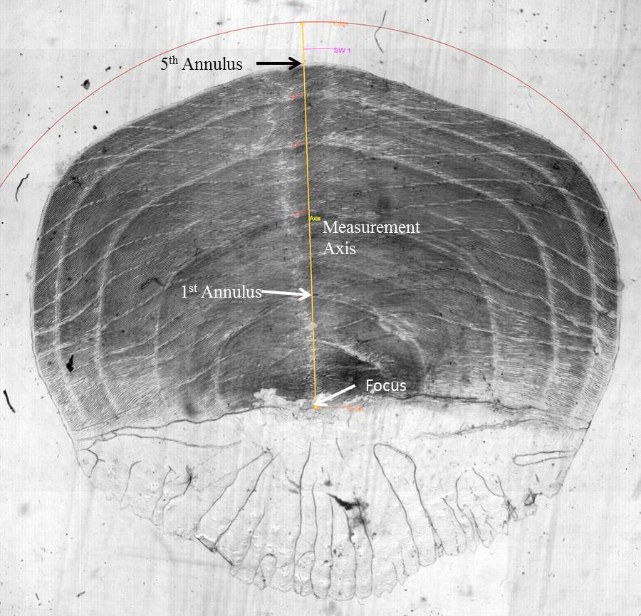

Figure 2–Example Pacific herring scale with measurement overlay from image analysis software

The focus, measurement axis, and each annulus are marked the scale. The number of annuli and the spacing between annuli were exported to a text file with the unique image name, date and time the measurement occurred, and reader initials. The text file data were imported into Excel (Microsoft Corporation, Redmond, WA) for analysis in Excel and SAS (SAS Institute, Inc., Cary North Carolina; Environmental Systems Research Institute, Inc., Redlands, California).

Quality Control

Scale measurements were examined for outliers by (1) filtering in Excel to examine the range of measurements and (2) using SAS Proc SGPlot to make scatter plots and box plots of each annular measurement by age, sex, and year. Scales identified as outliers in box plots were measured a second time. The reader was not informed that these scales had been measured previously to reduce the possibility of a different process being followed for the second measurements. Paired measurements by age and scale annulus (14 combinations) were examined with SAS Proc Univariate and quantile-quantile plots. Because the differences between paired data for each age and scale annulus were mostly non-normally distributed, a Wilcoxon signed-rank test (Zar 1996) was used to test the null hypothesis that the median difference between paired observations is zero.

Precision Test

The precision of measurements was evaluated by randomly selecting 101 scales from fish aged 4, 5, and 6 to measure a second time. As previously discussed for the outliers that were re-measured, the reader was not informed that these scales had been measured previously to reduce the possibility of a different process being followed for the second measurements. Paired measurements were examined with SAS Proc Reg to calculate a linear regression model for each scale growth annulus with ages and sexes combined (1 through 6). Regression models were also examined for individual ages (4,5, or 6) with the sexes combined.

Growth Correlations

Herring scale annular measurements, historical herring biomass, and historical herring recruitment estimates were tested for normality with quantile-quantile plots in SAS Proc Univariate. Pearson product-moment correlation coefficients (Zar 1996) were calculated between herring scale annular measurements for ages 4–6 (scale growth annuli in the same growth year) and the natural log of herring biomass using SAS Proc Corr. Historical adult herring biomass (biomass recruited to the spawning population) and recruitment data are from an Alaska Department of Fish and Game age structured model (Steve Moffitt, Alaska Department of Fish and Game, unpublished data). Adult herring biomass data were natural log transformed to normalize the data prior to using it in correlation analysis.

Results

Scale Images and Measurements

A total of 7,270 Pacific herring scales were imaged and measured (Table 1). The sample size averaged >35 fish by age, sex, and year and >30 fish for 88% of the 136 age, sex, and year combinations (Appendix A.1).

Table 1–Count of Pacific herring scales imaged and measured for annular growth increments, 1982, 1983, and 1986–2015.

*Note:* F= female and M = Male

An additional 3,300 scales were imaged, but not measured because either (1) the reader did not agree with the originally assigned age or (2) the scale had morphological problems that made it unlikely to work for measuring.

Quality Control

Examination of scatter plots and box plots located 57 scales with measurements that were outliers for one or more annular measurement. All of these scales were imaged and measured a second time. Examination of the paired measurements with SAS™ Proc Univariate quantile-quantile plots indicated the differences between the measurements were not normally distributed. Only 1 of the 14 combinations of age and scale growth increment was significantly different at a P<0.05 (Table 2).

Table 2–Wilcoxon signed-rank tests of paired measurements of scales marked as outliers.

|  |  |  |  |  |
| --- | --- | --- | --- | --- |
| Scale |  | Age | | |
| Increment |  | 4 | 5 | 6 |
| First | N | 22 | 22 | 13 |
|  | P | 0.7181 | 0.1256 | 0.8926 |
| Second | N | 22 | 22 | 13 |
|  | P | 0.7897 | 0.8385 | 0.1226 |
| Third | N | 22 | 22 | 13 |
|  | P | 0.4172 | **0.0466** | 0.8926 |
| Fourth | N | 22 | 22 | 13 |
|  | P | 0.0544 | 0.3669 | 0.2104 |
| Fifth | N | NA | 21 | 13 |
|  | P | NA | 0.920 | 0.4973 |

*Note:* N = sample size and P= probability that the median of the difference

between paired measurements is zero. Bold notes significance at 0.05.

Precision Test

All linear regression models of paired measurements of scale annuli (ages 4–6 combined) to test the precision were highly significant (Table 3).

Table 3–Results of linear regression models of paired measurements of randomly selected herring scales aged 4-6 combined.

|  |  |  |  |  |
| --- | --- | --- | --- | --- |
| Annular Increment | Observations | R2 | F Value | Pr > F |
| First | 101 | 0.94 | 1443 | <.0001 |
| Second | 101 | 0.96 | 2661 | <.0001 |
| Third | 101 | 0.91 | 1039 | <.0001 |
| Fourth | 101 | 0.94 | 1510 | <.0001 |
| Fifth | 81 | 0.91 | 778 | <.0001 |
| Sixth | 40 | 0.92 | 434 | <.0001 |

Growth Correlations

Herring aged 4–6 had statistically significant positive correlations in first-year scale growth within the same growth year (Table 4). However, the natural log of adult herring biomass estimates and first-year herring scale growth were negatively correlated, but the correlations were not significant (e.g., Figure 3). Herring recruitment data were not used in this analysis because they were not sufficiently normalized by a log transformation.

Table 4–Pearson correlation coefficients of the first year of herring scale growth by age (sexes combined) and the log of age structured model estimates of adult herring biomass for growth years 1976-2011.

|  |  |  |  |  |
| --- | --- | --- | --- | --- |
| Prob > |r| under H0: Rho=0 | | | | |
|  | Age 4 Growth | Age 5 Growth | Age 6 Growth | Log(Biomass) metric tons |
| Age 4 Growth | 1.0 |  |  |  |
|  |  |  |  |  |
| Age 5 Growth | 0.893 | 1.0 |  |  |
|  | <.0001 |  |  |  |
| Age 6 Growth | 0.820 | 0.796 | 1.0 |  |
|  | <.0001 | <.0001 |  |  |
| Log(Biomass) metric tons | -0.244 | -0.229 | -0.165 | 1.0 |
|  | 0.201 | 0.233 | 0.391 |  |

Figure 3–Average scale growth annuli (mm) and 95% confidence intervals for the first year of growth of age-6 Pacific herring captured in early spring in Prince William Sound, Alaska for Growth years 1980–2009.

Discussion

Scale Images and Measurements

The original objectives of this study were focused on developing appropriate criteria and techniques to image and measure as many herring scales as possible in a short time period. The program also limited its scope to 3 age classes to help ensure measuring a sufficient number of scales each year to allow meaningful assessment of changes in growth among years. A much smaller sample size could be used to generate a defensible age composition for a season, but the ability to measure 30 or more useable scales for multiple age classes within a year requires much larger sample sizes. In this project ~31% of the randomly selected scales were not measured because the reader did not agree with the original age assigned or the scale had morphological issues that made it unusable. Many of these scales may still be useable after reassessment of the age. However, the high rejection rate suggests that a review of scale collection and age training and inseason assessment should be conducted.

Quality Control

Examination of the statistical outliers paired with data from a second measurement showed no significant difference when tested with combined age and sex data for each scale annulus. This suggests that most of the outliers were natural biological outliers and not an indication of differences in the way the paired measurements were generated, e.g., choosing a different axis line to measure along. However, testing by individual ages may have detected differences in future assessments. Because no differences were found in 13 of 14 age-scale annuli combinations, the statistical outliers were not removed from the production data.

Precision Test

It was reassuring that the precision assessments provided highly significant relationship between the paired measurements. Only one reader worked on this project, so no between reader comparisons were possible. In future programs to measure significant numbers of scales, the precision assessment should be part of the initial training and conducted with smaller sample sizes (30 to 50) multiple times during the project; however, it will be difficult to make second measurements blind to the reader.

Growth Correlations

The scale growth correlations for fish collected at different ages from the same brood year is again reassuring. The variability in growth shown in Figure 3 would suggest there should be some environmental variable that could at least act as a proxy to the sum of variables that affect scale growth for larval fish. Batten et al. (2016) found that July and August water temperature has a significant positive correlation with first-year scale growth (except in the warmest years) using scale growth data from this study. They also found a strong relationship between Continuous Plankton Recorder diatom anomalies and first-year herring scale growth that extended into the warmest years. These results provide more evidence that longitudinal growth histories can provide value in untangling the way that herring scale growth is influenced by environmental conditions.

CONCLUSIONS

The major objective of this study was to build a defensible, retrospective, longitudinal history of scale growth for Pacific herring in the Prince William Sound Management Area. The scale growth history data could then be used along with other environmental and biological data to try to untangle some of the influences on herring scale growth. Significant progress was made in developing the growth history dataset, conducting quality control, and assessing the precision of the scale increment measurements. Additionally, the dataset has already been used to evaluate some environmental and biological data.

Acknowledgements

Ron Andersen helped develop the procedures used in Cordova and completed all the scale imaging and measuring work. The project would not have been possible without Ron’s diligent, hard work. I would also like to thank staff at the Statewide Mark Tag and Age Lab (MTA) in Juneau. Tim Frawley helped us with the process to use the measurement macro tool designed for salmon to get the measurements we needed from herring. Lorna Wilson and Detlef Buettner shared their expertise about the equipment and procedures developed at the MTA Lab and knowledge about herring scale age interpretation.

Literature Cited

Anthony, V.C. and M.J. Fogarty. 1985. Environmental effects on recruitment, growth, and

vulnerability of Atlantic herring (*Clupea harengus harengus*) in the Gulf of Maine Region. Canadian Journal of Fisheries and Aquatic Sciences 42 (Supl 1):158-173, 1985.

Baker, T.T., J.A. Wilcock, and B.W. McCracken. 1991. Stock assessment and management of Pacific herring in Prince William Sound, 1990. Alaska Department of Fish and Game, Division of Commercial Fisheries. Technical Fisheries Data Report No. 91-22, Juneau.

Batten, S.D., S. Moffitt, W.S. Pegau, and R. Campbell. 2016. Plankton Indices explain interannual variability in Prince William Sound herring first year growth. Fisheries Oceanography 25: 420–432.

Chambers, R.C. and T.J. Miller. 1995. Evaluating fish growth by means of otolith increment

analysis: special properties of individual-level longitudinal data. Pages 155-175 *in* Secor, D.H., J.M. Dean, and S. E. Campana, editors. Recent Developments in Fish Otolith

Research. University of South Carolina Press, Columbia, South Carolina.

Elston, R.A. and T.R. Meyers. 2009. Effect of viral hemorrhagic septicemia virus on Pacific herring in Prince William Sound, Alaska from 1989 to 2005. Diseases of Aquatic Organisms. 83: 223–246.

Hagen, P.T., D.S. Oxman, and B.A. Agler 2001. Developing and deploying a high resolution imaging approach for scale analysis. (NPAFC Doc. 567). 11 p. Mark, Tag, and Age Lab, Alaska Department of Fish and Game, P.O. Box 25526, Juneau, Alaska.

Hagen, P.T., and T.J. Quinn II. 1991. Long-term growth dynamics of young pacific halibut:

evidence of temperature-induced variation. Fisheries Research 11: 283-306.

Haist, V. and M. Stocker. 1985. Growth and maturation of Pacific herring *(Clupea pallasi)* in

the Strait of Georgia. Canadian Journal of Fisheries and Aquatic Sciences 42 (Supl 1):138-146, 1985.

Lebida, R.C. 1986. A pictorial guide to age interpretation of Bering Sea Pacific herring, *Clupea harengus pallasi,* scales. Alaska Department of Fish and Game, Division of Commercial Fisheries, Bristol Bay Data Report 86-5, Anchorage.

Marty, G.D., E.F. Freiberg, T.R. Meyers, J. Wilcock, T.B. Farver, and D.E. Hinton. 1998. Viral

hemorrhagic septicemia virus, *Ichthyophonus hoferi,* and other causes of morbidity in

Pacific herring *Clupea pallasi* spawning in Prince William Sound, Alaska, USA. Diseases of Aquatic Organisms 32(1): 15-40.

Marty G.D., Hulson P-J. F., Miller S.E., Quinn T.J. II, Moffitt S.D., Merizon R.A. 2010. Failure of population recovery in relation to disease in Pacific herring. Diseases of Aquatic Organisms 90:1–14.

Marty G.D., Quinn T.J. II, Carpenter G., Meyers T.R., Willits N.H. 2003. Role of disease in abundance of a Pacific herring (*Clupea pallasi*) population. Canadian Journal of Fisheries and Aquatic Sciences 60:1258–1265.

Methot, R.D. 1997. Applications of Environmental Data in Fishery Assessments. pp. 30–33 *in*:

Boehlert, G.W. and J.D. Schumacher, eds. Changing Oceans and Changing Fisheries:

Environmental Data for Fisheries Research and Management. NOAA Tech. Memo.

NOAA-TM-Nlv1FS-SWFSC-239. 146 p.

Peterman, R.M. and M. J. Bradford. 1987. Density-dependent growth of age 1 English sole

(*Parophrys vetulus*) in Oregon and Washington coastal waters. Canadian Journal of Fisheries and Aquatic Sciences 44: 48-53.

Rice S.D. and Carls M.G. 2007. Prince William Sound herring: an updated synthesis

of population declines and lack of recovery, *Exxon Valdez* Oil Spill Restoration Project Final Report (Restoration Project 050794), National Oceanic and Atmospheric Administration, National Marine Fisheries Service, Auke Bay Laboratory, Juneau, Alaska.

Sandone, G.J. 1988a. Age, sex, and size composition of Pacific herring sampled from the Prince William Sound Management Area, 1973–1983. Alaska Department of Fish and Game, Division of Commercial Fisheries, Prince William Sound Management Area Report 88-06, Anchorage.

Sandone, G.J. 1988b. Age, sex, and size composition of Pacific herring sampled from the Prince William Sound Management Area, 1984–1987. Alaska Department of Fish and Game, Division of Commercial Fisheries, Regional Information Report 2A88-18, Anchorage.

Schmitt, C. C and B. E. Skud. 1978. Relationship of Fecundity to long-term changes in growth,

abundance and recruitment. International Pacific Halibut Commission, Scientific Report

66, 31 p.

Stocker, M., V. Haist, and D. Fournier. 1985. Environmental variation and recruitment of Pacific

herring *(Clupea harengus pallasi)* in the Strait of Georgia. Canadian Journal of Fisheries and Aquatic Sciences, 42, 174-180.

Tanasichuk, R.W. 1997. Influence of biomass and ocean climate on the growth of Pacific herring

*(Clupea pallasi)* from the southwest coast of Vancouver Island. Canadian Journal of Fisheries and Aquatic Sciences,

54, 2782-2788.

Ware, D.M., and R.W. Tanansichuk. 1989. Biological basis of maturation and spawning waves

in Pacific herring *(Clupea harengus pallasai).* Canadian Journal of Fisheries and Aquatic Sciences, 46(10): 174-180.

Weatherley, A. H. and H. S. Gill. 1987. The Biology of Fish Growth. Academic Press, London,

443 p.

Weisberg S. 1993. Using hard-part increment data to estimate age and environmental effects.

Canadian Journal of Fisheries and Aquatic Sciences 50(6):1229-1237.

Willette, T.M., G.S. Carpenter, K. Hyer, and J.A. Wilcock. 1999. Herring natal habitats, *Exxon Valdez* Oil Spill Restoration Project Final Report (Restoration Project 97166), Alaska Department of Fish and Game, Division of Commercial Fisheries, Cordova, Alaska.

Zar, J.H. Biostatistical analysis. 3rd Edition. Prentice-Hall, Inc., Upper Saddle River. 662 pages.

Appendices

Appendix 1–Count of Prince William Sound Pacific herring scales that were imaged and growth annuli measured by year. No scales were measured for 1984.

